Concordia University

Department of Computer Science and Software Engineering

COMP 6231: Distributed Systems Design

STOCK BROKER SYSTEM: PROJECT MILESTONE #4

Team 3

Gay Hazan
Ross Smith
Patrick Cristofaro

August 18, 2015

Table of Contents
Overview 3
Architecture 3
Design 4
Replication Front End 4
Sequencer component 5
Replica Manager component 6
Replica component 6
UDP messaging scheme 8
Improvements 8
Running the Package 9
Management 9
Release Notes 9
References 10

Overview
This project implements reliable system for a stock exchange service, including a broker, a number of businesses, and an arbitrary number of clients.
“Stockbrokers receive requests from clients, buy/sell stocks on various stock exchanges. The application will have to query a real external stock quotes service, e.g., such as that of Yahoo, and simulate trades locally.” [Mokhov]
The final project milestone introduces the concept of reliability to the overall system, by adding replication managers, a sequencer and a front end, as shown below in Illustration 1.

Architecture
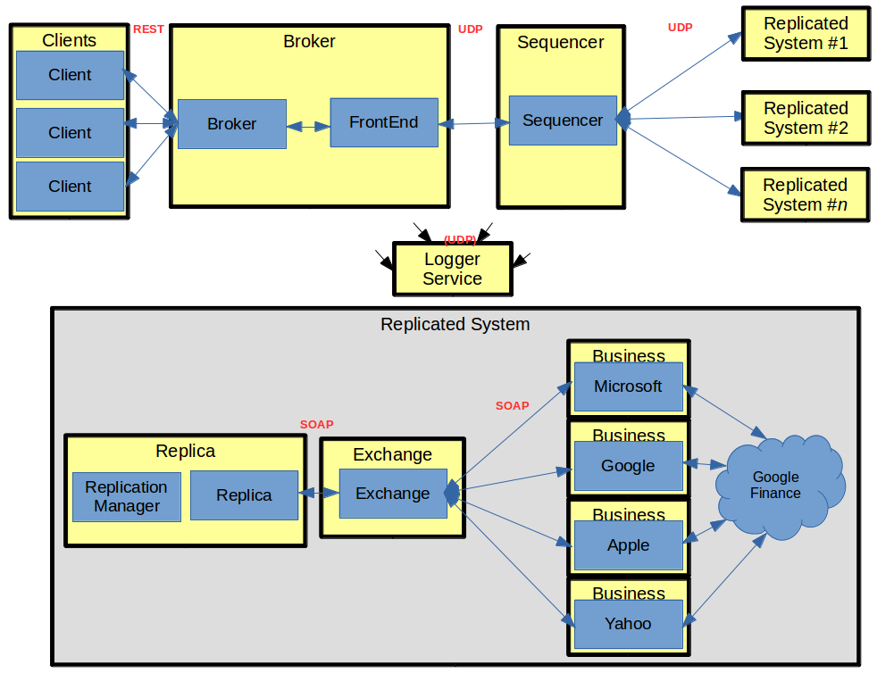
Illustration 1: Architecture of the Stock Exchange, adapted from [Mokhov]
The system has numerous different server types, all running concurrently.
Client Server initiates orders and purchase shares by connecting to the broker. The system supports an arbitrary number of clients.
Stock Broker implements the broker class to initiate the purchase of shares.
A front end passes requests on to the replicated systems and determines when correct results are received.
Sequencer receives messages and adds a sequence number to the message for reliability purposes.
The Replica server maintains heartbeats, coordinates requests and ensures total order delivery of messages.
Exchange Servers implement the exchange class and receives SOAP requests.
Business servers represent individual companies with shares to sell. The system supports an arbitrary number of businesses, and retrieves stock prices from an internet web service (Google Finance).
Logger server collects information and error messages, saving them locally in a log file.
All communications between servers use either a Web Service implementation or simple UDP messaging.

Design
In this section, we will take a more detailed look at each new architectural component, including the rationale behind our design decisions. We will also address some of the overall improvements made since the previous iteration.
The main focus of the discussion will be on new implementation relevant to this milestone.

Replication Front End
As of the last project milestone, the Broker component sent orders directly to the appropriate Exchange. For this milestone, the broker must pass requests through a Front End that acts as a proxy to the replicated systems. This change is virtually transparent to the Broker, but adds significant reliability to the overall system.
When the Apache Tomcat server receives a request to the RESTful Broker it calls the Front End, which in turn sends a UDP message to the sequencer and then starts up a blocking server. The UDP message sent to the sequencer also contains the port number of this new blocking server. The Front End will wait until it receives a response to the request, then unblocks and continues execution and returns the result to the client.
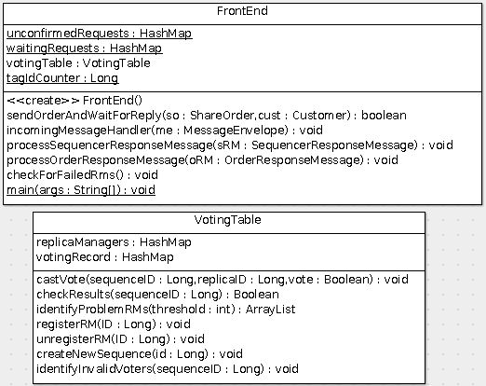Illustration 2: Methods of the FrontEnd component

Sequencer component
The sequencer receives messages and stamps them with a sequence number to ensure a totally ordered system. It keeps a record of all the active replication managers and multicasts new requests to all of them. Responses are then received by the sequencer before being passed back to the Replication Front End.
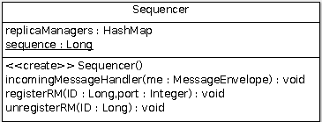Illustration 3: Features of the Sequencer

Replica Manager component
After finding an open port, the RM starts up and sends a message to the sequencer to signal that it is up and running. The RM then starts a heartbeat thread and waits for any incoming messages. The heartbeat thread sends a message to all other replicas that the replica knows about. The replica manager can receive three different message types:
- Heartbeat message: When received the RM takes a timestamp and saves it to memory. When a heartbeat message is received, in addition to adding this timestamp, the RM checks to see if the any of the timestamps it recorded are older than 15 seconds. If yes, it assumes the remote RM has failed and starts the process of removing the record from local memory, as well as telling the sequencer to unregister the RM and start a new one.
- Port message: When the RM receives this message it adds the port to its tracked list of active RM's, this message comes from the sequencer add is intended to let the RM's know who they should be sending heartbeats too
- Order message: When the RM receives this message it passes it on to the Replica.
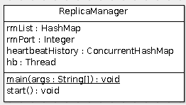
Illustration 4: The Replica Manager

Replica component
Each replica receives order messages from the RM and does the following:
- Verifies if the sequence of the message is the next sequence expected. If so, the replica prepares the order and sends it via a SOAP message to the exchange. The exchange process the order. Once the response is received from the exchange the replica sends a confirmation to the front end via UDP.
- If the sequence received is not the expected sequence number then the replica will store the order message in the hold back queue in ascending order, by sequence number.
- After the replica has processed a message it will check the next element in the hold back queue and process it if the sequence number is the expected one.

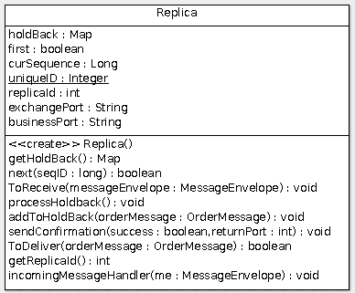
Illustration 5: The Replica

UDP messaging scheme
We have developed a messaging scheme for passing objects over UDP. The replication.messageObjects package contains all the possible messages used by our reliable system. To send a message, the object is encapsulated inside a MessageEnvelope object and passed over UDP to the destination. See the illustration below for a summary of all message types.
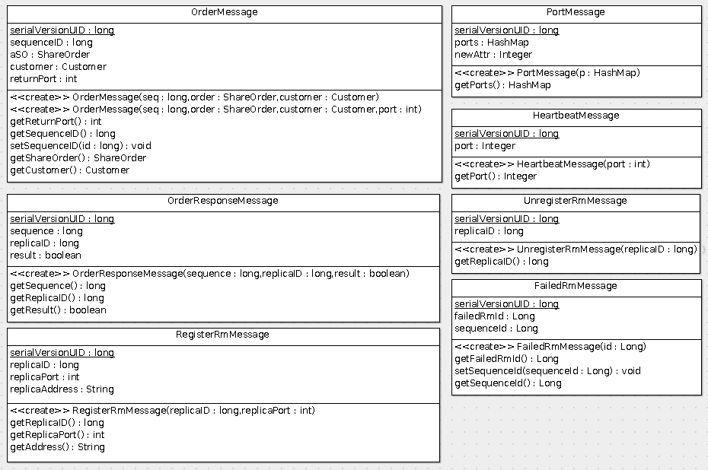Illustration 6: Overview of all available UDP message objects

Improvements
Our third iteration had only one recommendation which has been integrated for this final submission:
- Clean your build before submitting to avoid sending class files in out dir.

Running the Package
To run the package, first ensure that the Apache Tomcat server is up and running as described in the README.md file.
Then, visit http://localhost:8080/project/buyShares to instantiate the RESTful server.
Next, run each of the following classes as Java projects in the following order:
- common.logger.LoggerServer.java
- relpication.Sequencer.java
- replication.ReplicaManager.java
  - Run this class once for every replica you want to create
- clientFrontEnd.frontEnd.java

Management
For this milestone, we continued to use JIRA Agile as our primary tool for coordinating tasks between team members. The server is located at http://jira.homelinux.org. Access can be provided on request.
Illustration 7: JIRA Agile continues to be the project's task-management system

Release Notes
Please see the README.md in the project root folder for important details about this release, including basic instructions on running and links to the detailed Javadoc.

References

[Mokhov] | Mokhov, Serguei A. COMP6231: Distributed Systems Design TENTATIVE PROJECT DESCRIPTION, updated August 2015.
[Oracle] | http://docs.oracle.com/javase/7/docs/api/java/util/ArrayList.html, June 27, 2015.
[IBM] | http://www.ibm.com/developerworks/library/ws-restful/
[Nordic] | http://nordicapis.com/rest-vs-soap-nordic-apis-infographic-comparison/
[Oracle2] | http://www.oracle.com/technetwork/articles/java/restful-142517.html
[JavaT] | http://www.javatpoint.com/soap-vs-rest-web-services
[Oracle3] | http://www.oracle.com/technetwork/java/tutorial-138750.html

